Different types of network devices and cables
Prepared by : S Abdul Rehman
(2 nd Bsc (C.S))

- Network Devices
Network devices help in data transmission, network management, and communication. These devices operate at different OSI model layers.

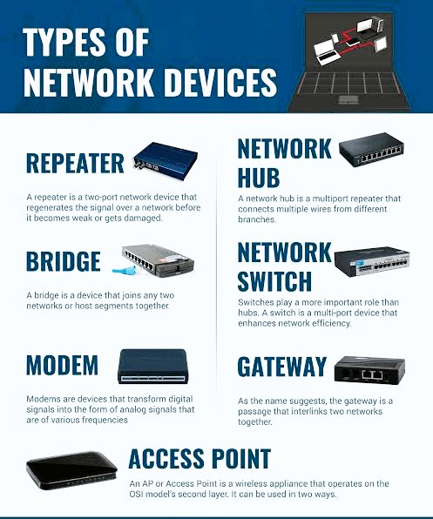

A. Passive Network Devices
These devices do not process data but help in connection.
- Hub
Works at Layer 1 (Physical Layer).
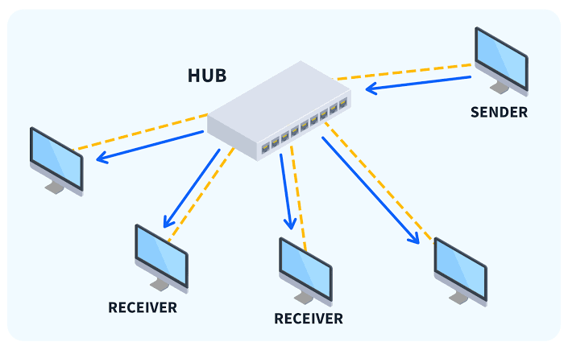
Function:
Broadcasts data to all connected devices.
No intelligence; cannot filter traffic.
Types:
Active Hub – Needs power; amplifies signals.
Passive Hub – No power needed; just connects devices.
Intelligent Hub – Has some management capabilities.

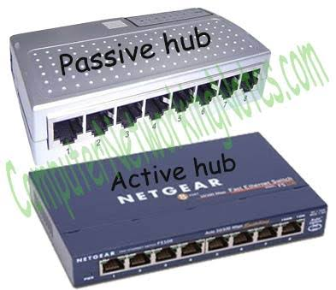

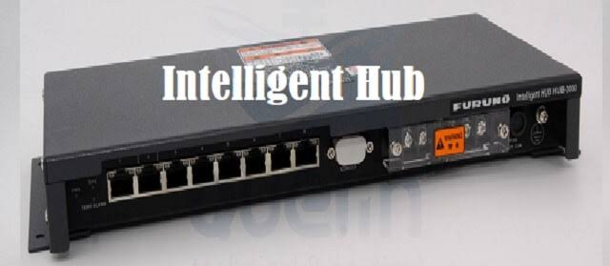
Uses:
Small networks for basic connectivity (e.g., old office networks).

2. Repeater
Works at Layer 1 (Physical Layer).
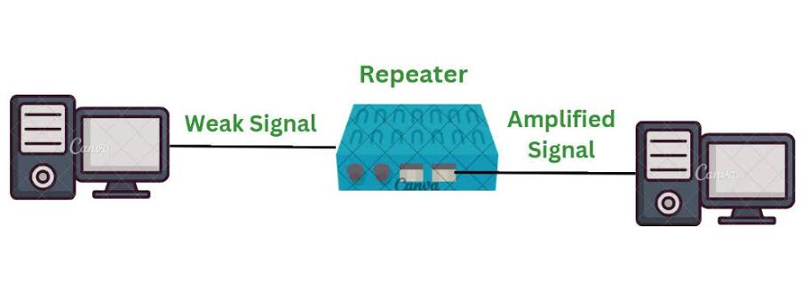

Function:
Amplifies and regenerates weak network signals.
Uses:
Extends network range (e.g., large buildings, campuses).
---

B. Active Network Devices
These devices process and direct network traffic.

3. Switch
Works at Layer 2 (Data Link Layer).
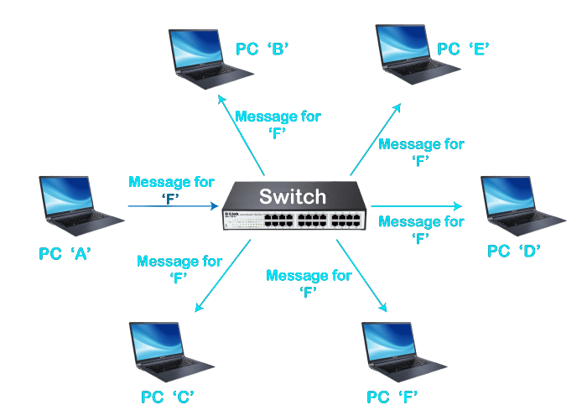

Function:
Uses MAC addresses to send data to specific devices.
Reduces network congestion.
Types:
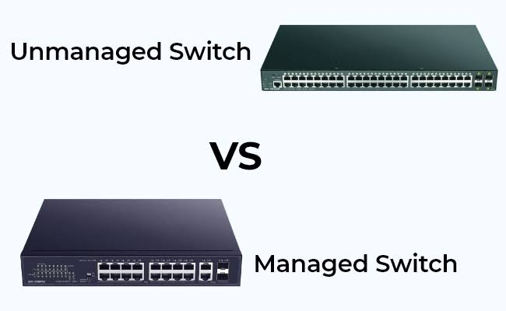
Unmanaged Switch – Simple, plug-and-play.
Managed Switch – Configurable, used in large networks.

Uses:
LAN networks (e.g., offices, colleges, data centers).

4. Router
Works at Layer 3 (Network Layer).
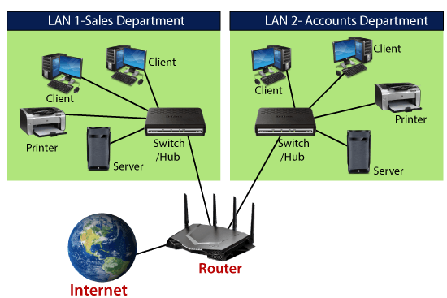

Function:
Routes data between different networks using IP addresses.
Connects LAN to the internet.
Types:
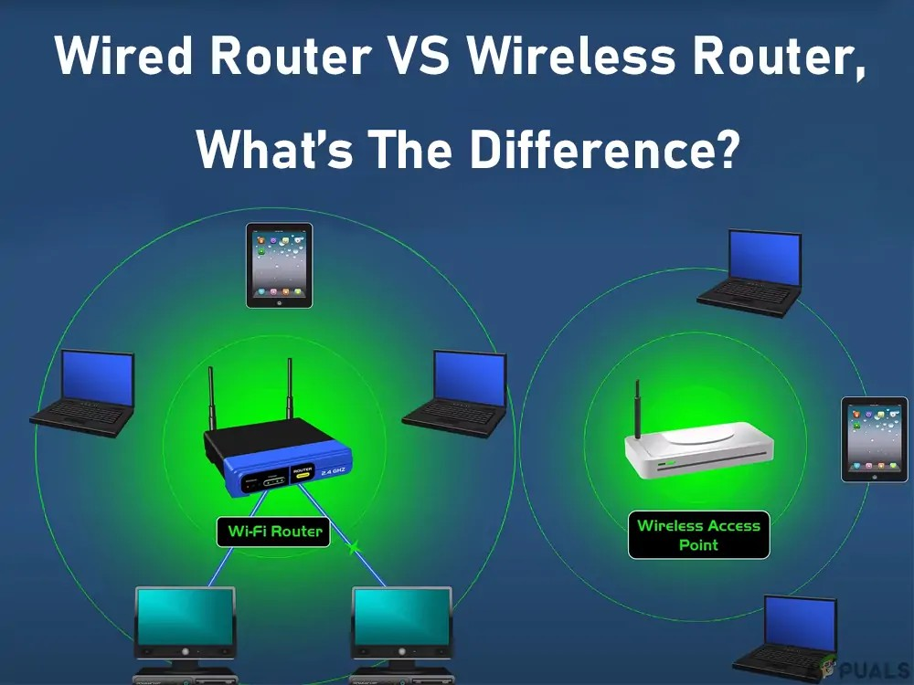

Wired Router – Uses Ethernet cables.

Wireless Router – Provides Wi-Fi connectivity.

Uses:
Home and office internet, large enterprise networks.

5. Modem (Modulator-Demodulator)
Works at Layer 1 (Physical Layer).
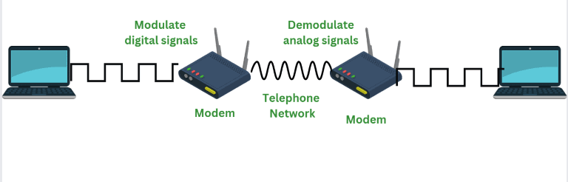

Function:
Converts digital data into analog (and vice versa) for internet access.
Types:

DSL Modem – Uses telephone lines.

Cable Modem – Uses coaxial cables.
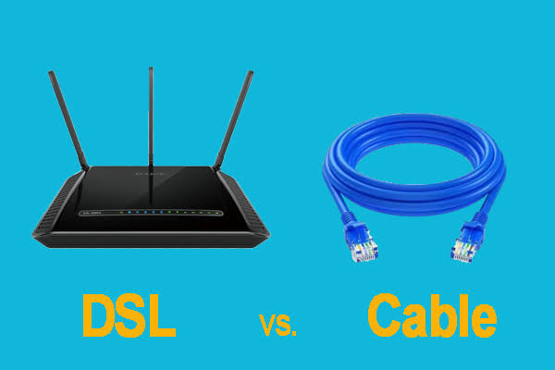

Uses:
Home broadband connections.

6. Access Point (AP)
Works at Layer 2 (Data Link Layer).
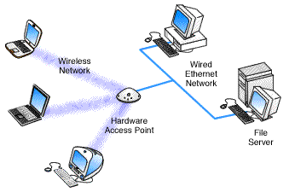

Function:
Extends wireless network coverage.
Types:

Standalone AP – Directly connects to the network.

Controller-based AP – Managed by a central device.
Uses:
Wi-Fi in offices, malls, airports.
7. Gateway
Works at Layer 3+ (Network, Transport, Application Layers).
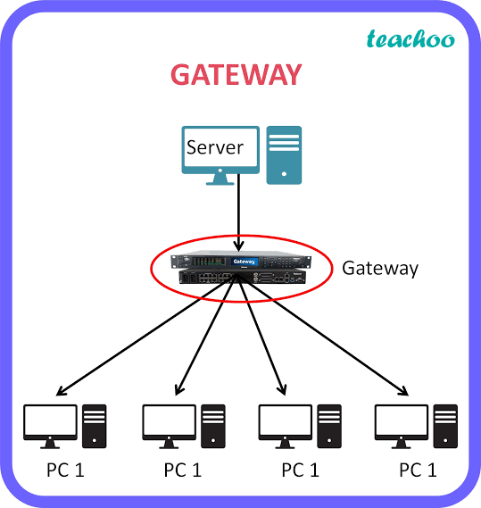

Function:
Connects different network protocols (e.g., IPv4 to IPv6).
Uses:
Cloud networks, large enterprises.

8. Firewall
Works at Layer 3, 4, and 7.
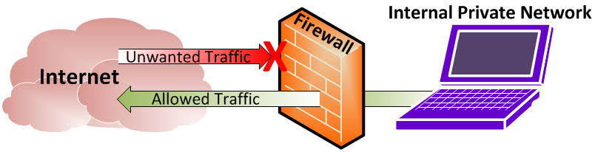

Function:
Monitors and controls incoming/outgoing traffic for security.
Types:

Hardware Firewall – Physical device securing networks.

Software Firewall – Installed on computers/servers.
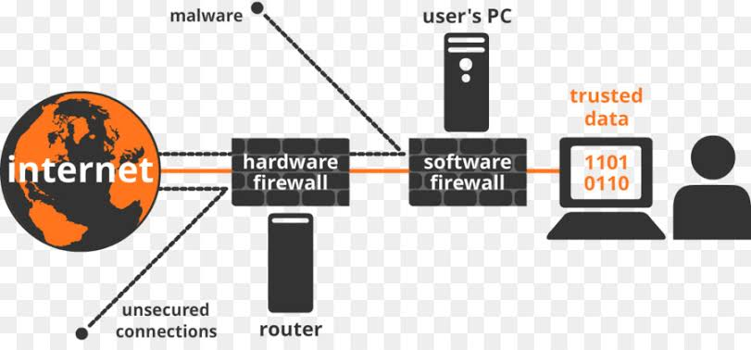

Uses:
Cybersecurity in businesses, government, banks.

9. Network Interface Card (NIC)
Works at Layer 2 (Data Link Layer).
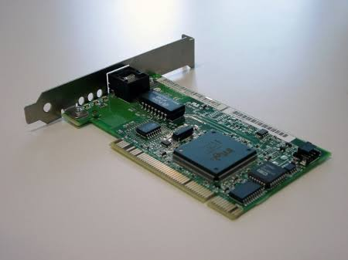

Function:
Provides physical connection to a network.
Types:

Wired NIC – Uses Ethernet cables.

Wireless NIC – Uses Wi-Fi.
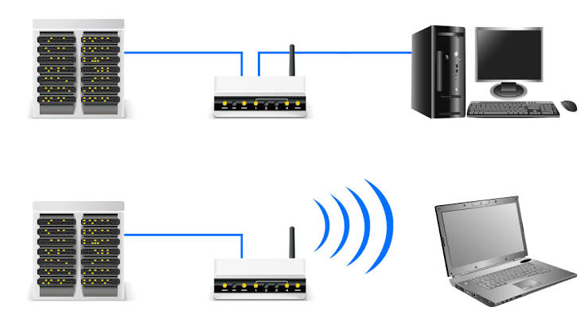

Uses:
Found in every computer, server, and networking device.
---

2. Network Cables
Cables are used for data transmission in wired networks.

- Twisted Pair Cable
Common in Ethernet networks.
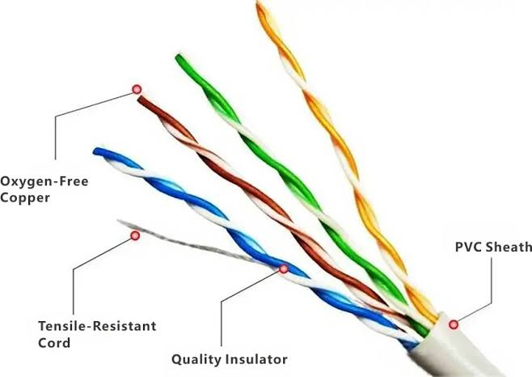
Structure:
Pairs of copper wires twisted to reduce interference.
Types:

Unshielded Twisted Pair (UTP) – No shielding, cheaper.
Shielded Twisted Pair (STP) – Shielded for better protection.
Categories:
Cat5 – Up to 100 Mbps.
Cat5e – Up to 1 Gbps, reduced interference.
Cat6 – Up to 10 Gbps over short distances.
Cat7 & Cat8 – Higher speeds, used in data centers.

Uses:
LAN networks, home and office setups.

B. Coaxial Cable
Used in older networks and cable TV.
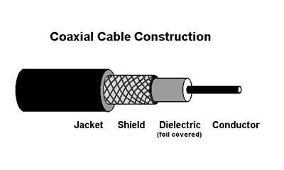
Structure:
Central conductor (copper), insulation, metallic shield, outer cover.
Types:

Thicknet – Long-distance, high bandwidth.

Thinnet – Short-distance, flexible.
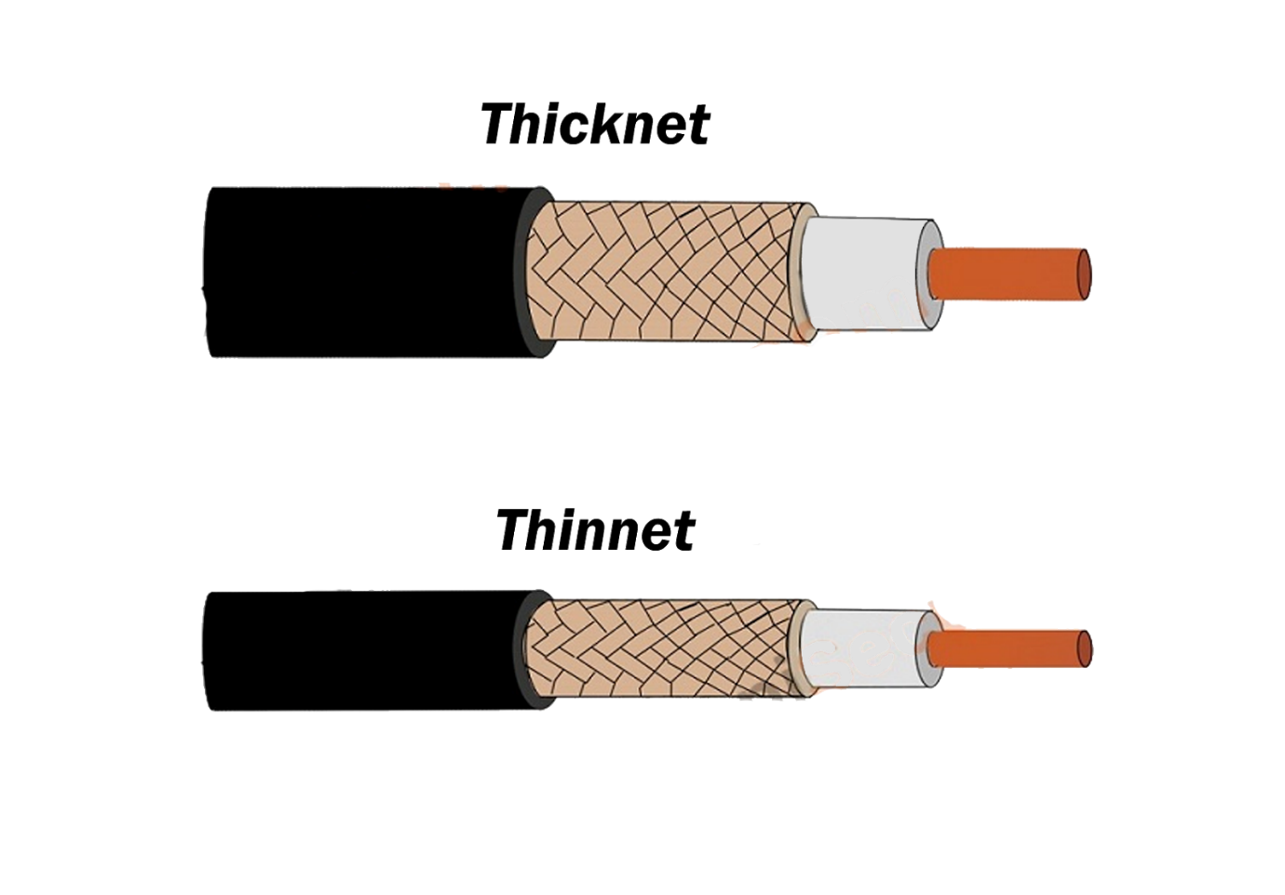

Uses:
CCTV cameras, cable broadband.

C. Fiber Optic Cable
Fastest data transmission, uses light signals.
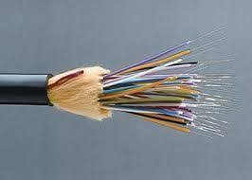
Structure:
Core (glass/plastic fiber), cladding, buffer coating, outer cover.

Types:

Single-mode fiber (SMF) – Long-distance, used in ISPs.

Multi-mode fiber (MMF) – Short-distance, used in LANs.
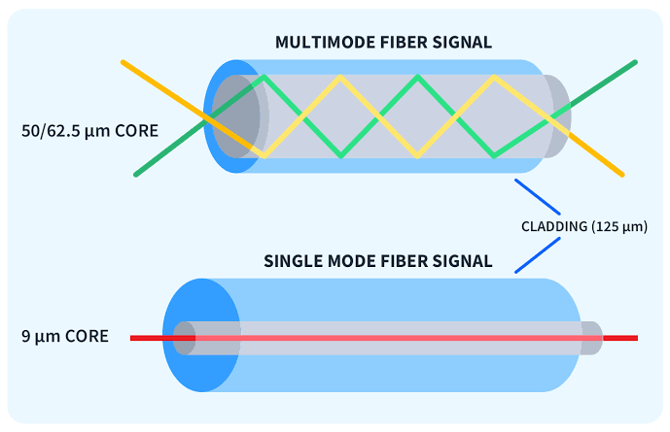
Uses:
High-speed internet, telecom, data centers.

D. Ethernet Cable (RJ-45)
Used for wired connections in LANs.
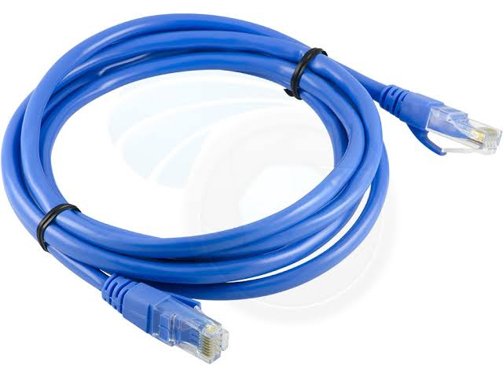
Structure:
Twisted pair cables inside with an RJ-45 connector.
Uses:
Connects PCs, routers, switches.
---

